TASK 12 – Day-4 design challenge
New requirements: add Airport zone fare Rs.60; apply a 10% weekend discount that does not combine with the 20% peak surcharge; add a monthly pass that allows unlimited travel in two selected zones.

A. Impact analysis
- Zone enum must gain Airport.
- Fare table must gain a fourth entry (6,000 paise).
- Fare calculation must receive a weekend flag.
- Weekend and peak rules must be mutually exclusive: if weekend, apply 10% discount; otherwise, if peak, apply 20% surcharge.
- SmartCard alone is not enough to represent a monthly entitlement; add a Pass class that stores two allowed zones and an active/valid status.

B. Evaluate the original design
The original switch can be extended by adding an Airport case, but a fare table is easier to extend as more zones are added. SmartCard can continue to manage stored money, but monthly-pass entitlement is a different responsibility and should be represented by a separate Pass class. A valid pass for a selected zone should allow the journey without deducting the normal stored-value fare, subject to the pass being active and the zone being one of its two selected zones.
Worked examples: Airport off-peak weekday fare = Rs.60.00. Airport peak weekday fare = Rs.72.00. Airport weekend fare = Rs.54.00. Weekend peak time still gives Rs.54.00 because the weekend discount and peak surcharge do not combine; the weekend rule takes priority.

C. Revised design – working example
Updated fare table and monthly Pass class
#include <iostream>
#include <array>
#include <algorithm>
enum class Zone { Inner, Middle, Outer, Airport };
constexpr long long FARES[] = {1000, 2000, 3000, 6000};
long long calculateFare(Zone zone, bool peak, bool weekend) {
int index = static_cast<int>(zone);
if (index < 0 || index >= 4) return -1;
long long base = FARES[index];
if (weekend) return base - (base * 10 / 100);
if (peak) return base + (base * 20 / 100);
return base;
}
class Pass {
private:
std::array<Zone, 2> allowedZones;
bool active;
public:
Pass(Zone first, Zone second, bool isActive = true)
: allowedZones{first, second}, active(isActive) {}
bool covers(Zone zone) const {
return active &&
(allowedZones[0] == zone || allowedZones[1] == zone);
}
};
int main() {
std::cout << "Airport weekday off-peak Rs "
<< calculateFare(Zone::Airport, false, false) / 100.0 << '\n';
std::cout << "Airport weekday peak Rs "
<< calculateFare(Zone::Airport, true, false) / 100.0 << '\n';
std::cout << "Airport weekend Rs "
<< calculateFare(Zone::Airport, true, true) / 100.0 << '\n';
Pass monthly(Zone::Inner, Zone::Airport);
std::cout << "Monthly pass covers Airport: "
<< (monthly.covers(Zone::Airport) ? "Yes" : "No") << '\n';
std::cout << "Monthly pass covers Outer: "
<< (monthly.covers(Zone::Outer) ? "Yes" : "No") << '\n';
}

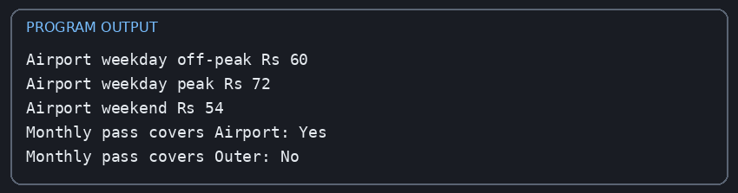
Executed output
Airport weekday off-peak Rs 60
Airport weekday peak Rs 72
Airport weekend Rs 54
Monthly pass covers Airport: Yes
Monthly pass covers Outer: No

Note: this example demonstrates the revised fare policy and pass-zone check. A complete production pass would also store an expiry date, pass identifier and renewal status, and the main journey-processing function would check the pass before deducting stored value. The assignment does not specify monthly-pass price or expiry-date format, so those details are left as design extensions rather than invented values.

D. Evidence-based defence
The recommended decision is MODIFY rather than completely redesign. Keep SmartCard encapsulation and integer-paise money handling. Replace the small switch with an indexed fare table for easier zone expansion, introduce a mutually exclusive weekend rule, and add a separate Pass class. This preserves tested original behaviour while separating the new pass entitlement from stored-value balance.

Complexity comparison
An array lookup is O(1); adding one zone requires one new fare entry and one enum value. Checking two pass zones is O(1). The additional pass stores two zones and a status flag, so its space is O(1). For a future pass covering many zones, a set could be used; membership lookup would depend on the chosen container.

Final submission checklist
- Fill in name, register number, class and submission date on the cover page.
- Run every C++ program using your own compiler and save genuine screenshots of the terminal output.
- Verify the exact output and compiler version on your computer; outputs may differ slightly by platform.
- Create the GitHub repository named DSA01-<RegisterNumber>-Assignment1.
- Put this report in the repository and place the corresponding .cpp source file(s) in Task01 through Task12 folders.
- Add input files and output screenshots to the relevant task folders.
- Write README.md with compiler/version, compile command (for example g++ -std=c++17 -Wall -Wextra), run instructions and a short result for each task.
- Make at least one meaningful commit per task; do not upload everything in one final commit.
- Add the working GitHub link to the report cover page and submit it as required.

Important items to confirm with faculty
- The scenario mentions student and senior-citizen concessions but does not state the concession percentage or exact eligibility conditions.
- The brief gives no monthly-pass price, expiry date rule or renewal policy.
- Confirm whether the faculty wants one combined final C++ program in addition to the task-wise programs.
Source basis: Assignment 1 [CO1], 13-page document provided by the student. This report follows its stated tasks, marks, scenario and submission requirements. Any assumptions or extensions are explicitly identified above.

